**ASSIGNMENT 5**

1. Code a script with the SQL statements to:
   * Use CREATE TABLE ... AS ... to create copies of the vendors and invoices tables, named vendors5 and invoices5, respectively,
     1. **CREATE TABLE VENDORS5 AS (SELECT * FROM VENDORS);**
     2. **CREATE TABLE INVOICES5 AS (SELECT * FROM INVOICES);**
   * Use ALTER statements to replicate the primary key, **all** foreign keys, and **all** constraints on the new tables to match the original ones. Foreign keys should reference the copy when possible.

**ALTER TABLE VENDORS5 ADD CONSTRAINT VENDORS5_PK PRIMARY KEY (VENDOR_ID);**

**ALTER TABLE VENDORS5 ADD CONSTRAINT VENDORS5_VENDOR_NAME_UQ UNIQUE (VENDOR_NAME);**

**ALTER TABLE VENDORS5 ADD CONSTRAINT VENDORS5_FK_TERMS FOREIGN KEY (DEFAULT_TERMS_ID) REFERENCES TERMS (TERMS_ID);**

**ALTER TABLE VENDORS5 ADD CONSTRAINT VENDORS5_FK_ACCOUNTS FOREIGN KEY (DEFAULT_ACCOUNT_NUMBER) REFERENCES GENERAL_LEDGER_ACCOUNTS (ACCOUNT_NUMBER);**

**ALTER TABLE INVOICES5 ADD CONSTRAINT INVOICES5_PK PRIMARY KEY (INVOICE_ID);**

**ALTER TABLE INVOICES5 ADD CONSTRAINT INVOICES5_FK_TERMS FOREIGN KEY (VENDOR_ID) REFERENCES VENDORS5 (VENDOR_ID);**

**ALTER TABLE INVOICES5 ADD CONSTRAINT INVOICES5_FK_VENDORS FOREIGN KEY (TERMS_ID) REFERENCES TERMS (TERMS_ID);**

* + Use an ALTER statement to add a column, named Balance, to invoices5. The data type should be the same as the other currency values.

**ALTER TABLE INVOICES5 ADD BALANCE NUMBER (9, 2) DEFAULT 0;**

* + Use an UPDATE statement to populate the balance due, which should contain the difference between the invoice total and the sum of the payment and credit.

**UPDATE INVOICES5**

**SET BALANCE = (INVOICE_TOTAL - (PAYMENT_TOTAL + CREDIT_TOTAL));**

1. Code a PL/SQL block (i.e. BEGIN ... END) with the statements to:
   * Add a new vendor and three (3) new invoices, with different totals, to the new tables. Added data should be in the same format as existing data.  
       
     The vendor name should be **'Your Name, LLC'**. (Not the literal "Your Name").  
       
     **Use 5 for the vendor, and invoice, terms.**  
       
     The invoice date should be set to the current date (system date, nothing hard-coded), and the due date should be the current date + 30 days.  
       
     The invoice total should include a cents amount, and the same value should be used for the balance due. Set the payment and credit to zero.  
       
     Add one (1) to the highest value in the table to set the key value for the new records. Do not hard-code any new key values - **use variables**.

**CREATE OR REPLACE PROCEDURE VENDORS5_INVOICES5_NEW_RECORDS**

**AS**

**P_VENDOR_ID NUMBER;**

**P_VENDOR_NAME VARCHAR2 (50):= 'Bhanumathi, LLC';**

**P_VENDOR_ADDRESS1 VARCHAR2 (50):= 'Jackson';**

**P_VENDOR_ADDRESS2 VARCHAR2 (50):= 'APT# 203';**

**P_VENDOR_CITY VARCHAR2 (50):= 'Chicago';**

**P_VENDOR_STATE CHAR (2):= 'IL';**

**P_VENDOR_ZIP_CODE VARCHAR2 (20):= '60616';**

**P_VENDOR_PHONE VARCHAR (50):= '(123) 456-8596';**

**P_VENDOR_CONTACT_LAST_NAME VARCHAR2 (50):= 'AAA';**

**P_VENDOR_CONTACT_FIRST_NAME VARCHAR2 (50):= 'BBB';**

**P_DEFAULT_TERMS_ID NUMBER:= 5;**

**P_DEFAULT_ACCOUNT_NUMBER NUMBER:= 100;**

**P_INVOICE_ID NUMBER;**

**P_INVOICE_NUMBER VARCHAR2 (50):= 'A1000';**

**P_INVOICE_DATE DATE:= SYSDATE;**

**P_INVOICE_TOTAL NUMBER (9, 2):= 100.10;**

**P_PAYMENT_TOTAL NUMBER (9, 2):= 0;**

**P_CREDIT_TOTAL NUMBER (9, 2):= 0;**

**P_TERMS_ID NUMBER:= 5;**

**P_INVOICE_DUE_DATE DATE;**

**P_PAYMENT_DATE DATE;**

**P_BALANCE NUMBER:= 0;**

**i NUMBER :=1 ;**

**BEGIN**

**SELECT MAX (VENDOR_ID) + 1 INTO P_VENDOR_ID FROM VENDORS5;**

**INSERT INTO VENDORS5 VALUES (P_VENDOR_ID,**

**P_VENDOR_NAME,**

**P_VENDOR_ADDRESS1,**

**P_VENDOR_ADDRESS2,**

**P_VENDOR_CITY,**

**P_VENDOR_STATE,**

**P_VENDOR_ZIP_CODE,**

**P_VENDOR_PHONE,**

**P_VENDOR_CONTACT_LAST_NAME,**

**P_VENDOR_CONTACT_FIRST_NAME,**

**P_DEFAULT_TERMS_ID,**

**P_DEFAULT_ACCOUNT_NUMBER);**

**WHILE i<4 LOOP**

**SELECT MAX (INVOICE_ID) + 1 INTO P_INVOICE_ID FROM INVOICES5;**

**SELECT SYSDATE + INTERVAL '30' DAY INTO P_INVOICE_DUE_DATE FROM DUAL;**

**INSERT INTO INVOICES5 VALUES (P_INVOICE_ID,**

**P_VENDOR_ID,**

**P_INVOICE_NUMBER,**

**P_INVOICE_DATE,**

**P_INVOICE_TOTAL,**

**P_PAYMENT_TOTAL,**

**P_CREDIT_TOTAL,**

**P_TERMS_ID,**

**P_INVOICE_DUE_DATE,**

**P_PAYMENT_DATE,**

**P_BALANCE);**

**P_INVOICE_TOTAL:= P_INVOICE_TOTAL + 2000;**

**i := i + 1;**

**END LOOP;**

**END;**

**/**

**EXECUTE VENDORS5_INVOICES5_NEW_RECORDS;**

* Update the credit in the new invoices for the new vendor, setting it to 10% of the invoice total (rounding to 2 decimal places), and also updating the balance due amount.

**CREATE OR REPLACE PROCEDURE UPDATE_CREDIT_BAL**

**AS**

**P_VENDOR_ID NUMBER (9, 2);**

**BEGIN**

**SELECT MAX (VENDOR_ID) INTO P_VENDOR_ID**

**FROM INVOICES5;**

**UPDATE INVOICES5**

**SET CREDIT_TOTAL = INVOICE_TOTAL * 0.1**

**WHERE VENDOR_ID = P_VENDOR_ID;**

**UPDATE INVOICES5**

**SET BALANCE = INVOICE_TOTAL – (PAYMENT_TOTAL + CREDIT_TOTAL)**

**WHERE VENDOR_ID = P_VENDOR_ID;**

**END;**

**/**

**EXECUTE UPDATE_CREDIT_BAL;**

1. Code the SQL statements to:
   * List the added records: vendor id & name, invoice id, 2 dates, and 3 currency values (omit payment).  
       
     Both dates should be displayed with the full month name, e.g. May 10, 2015, with no extra spaces after the name.

**SET LINESIZE 999**

**COLUMN VENDOR_NAME FORMAT A15**

**COLUMN INVOICE_TOTAL FORMAT A15**

**COLUMN CREDIT_TOTAL FORMAT A15**

**COLUMN BALANCE FORMAT A15**

**SELECT V.VENDOR_ID,**

**V.VENDOR_NAME,**

**I.INVOICE_ID,**

**TO_CHAR (I.INVOICE_DATE,'fmMONTHDD, YYYY’) AS INVOICE_DATE,**

**TO_CHAR (I.INVOICE_DUE_DATE, 'fmMONTHDD, YYYY’) AS INVOICE_DUE_DATE,**

**TO_CHAR (I.INVOICE_TOTAL, '$999,999,99.99') AS INVOICE_TOTAL,**

**TO_CHAR (I.CREDIT_TOTAL, '$999,999,99.99') AS CREDIT_TOTAL,**

**TO_CHAR (I.BALANCE, '$999,999,99.99') AS BALANCE**

**FROM VENDORS5 V**

**JOIN INVOICES5 I**

**ON V.VENDOR_ID = I.VENDOR_ID**

**WHERE V.VENDOR_ID = (SELECT MAX (VENDOR_ID) FROM VENDORS5);**

**OUTPUT:**

VENDOR_ID VENDOR_NAME INVOICE_ID INVOICE_DATE INVOICE_DUE_DATE INVOICE_TOTAL CREDIT_TOTAL BALANCE_DUE

---------- --------------- ---------- ---------------- ---------------- --------------- --------------- ---------------

124 Bhanumathi, LLC 115 OCTOBER26,2015 NOVEMBER25,2015 $1,00.10 $10.01 $90.09

124 Bhanumathi, LLC 116 OCTOBER26,2015 NOVEMBER25,2015 $21,00.10 $2,10.01 $18,90.09

124 Bhanumathi, LLC 117 OCTOBER26,2015 NOVEMBER25,2015 $41,00.10 $4,10.01 $36,90.09

* + Ensure the database is restored to its initial state, dropping created objects.

DROP TABLE INVOICES5;

DROP TABLE VENDORS5;

**OUTPUT:**

**Q1.A**

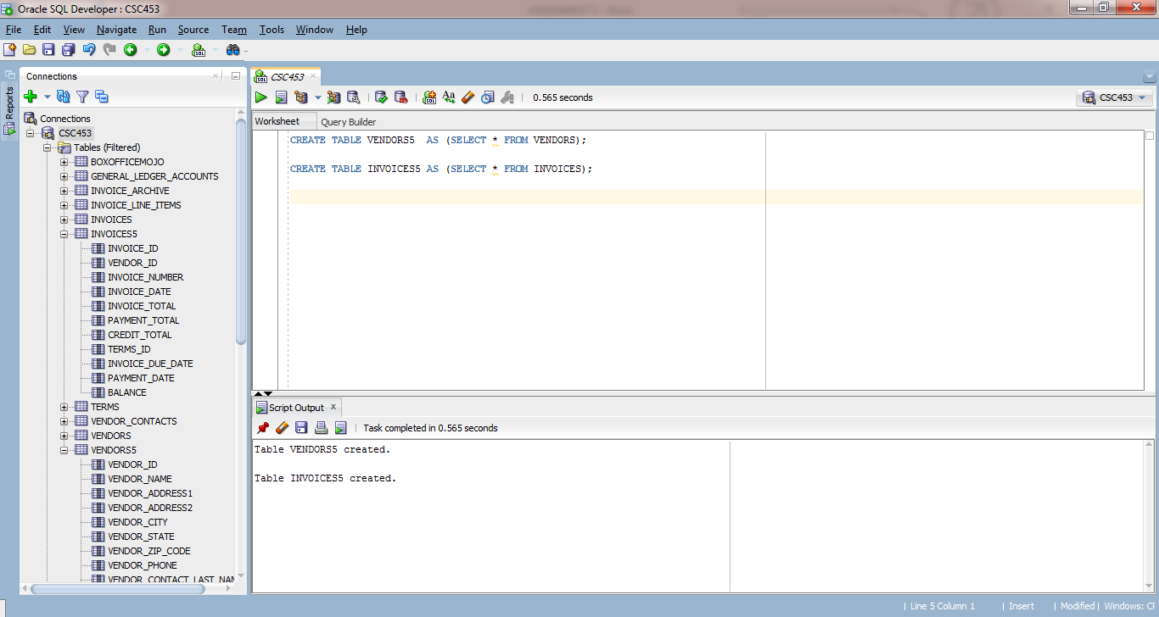

**Q1.B**

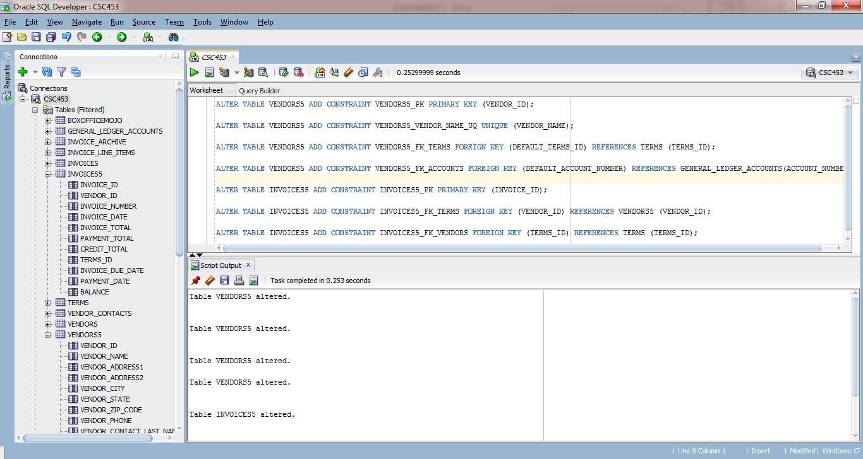

**Q1.D**

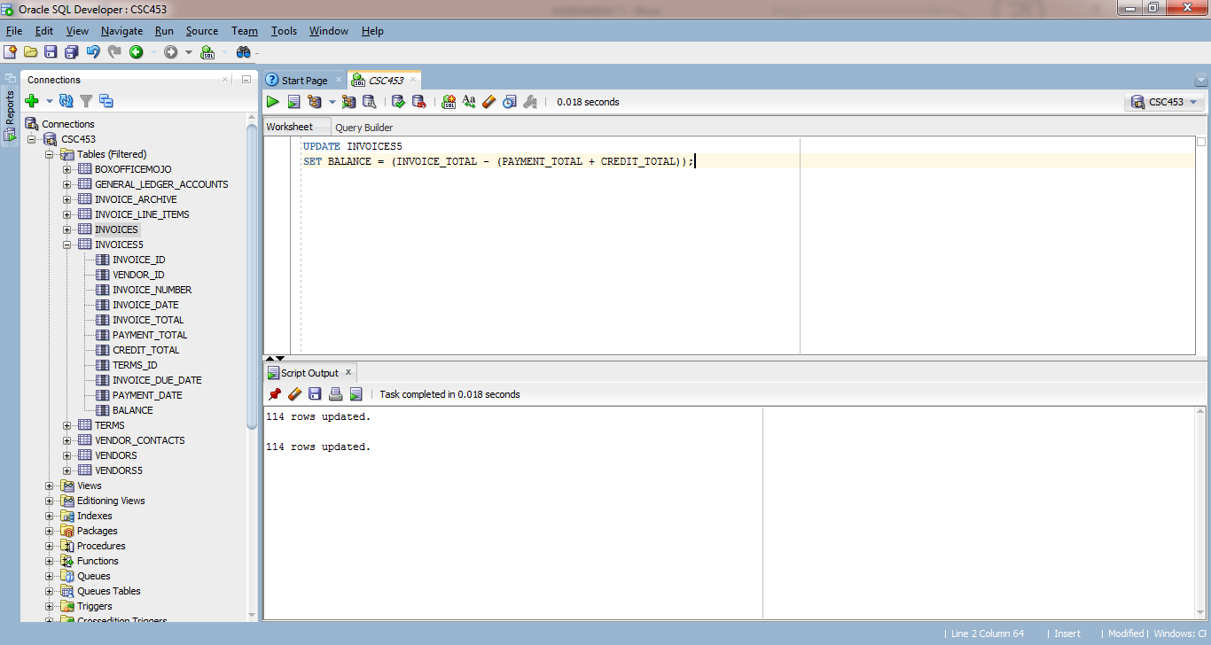

**Q2.A**

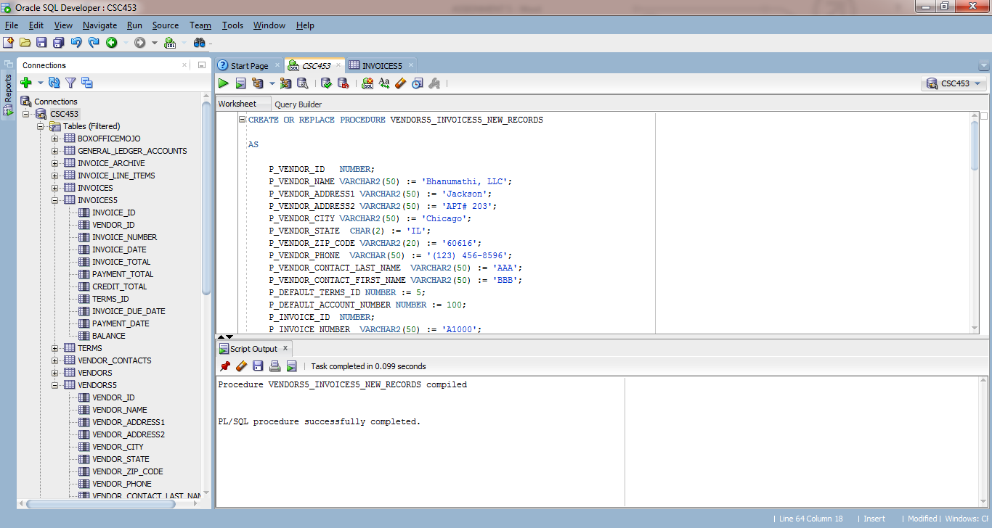

**Q2.B**

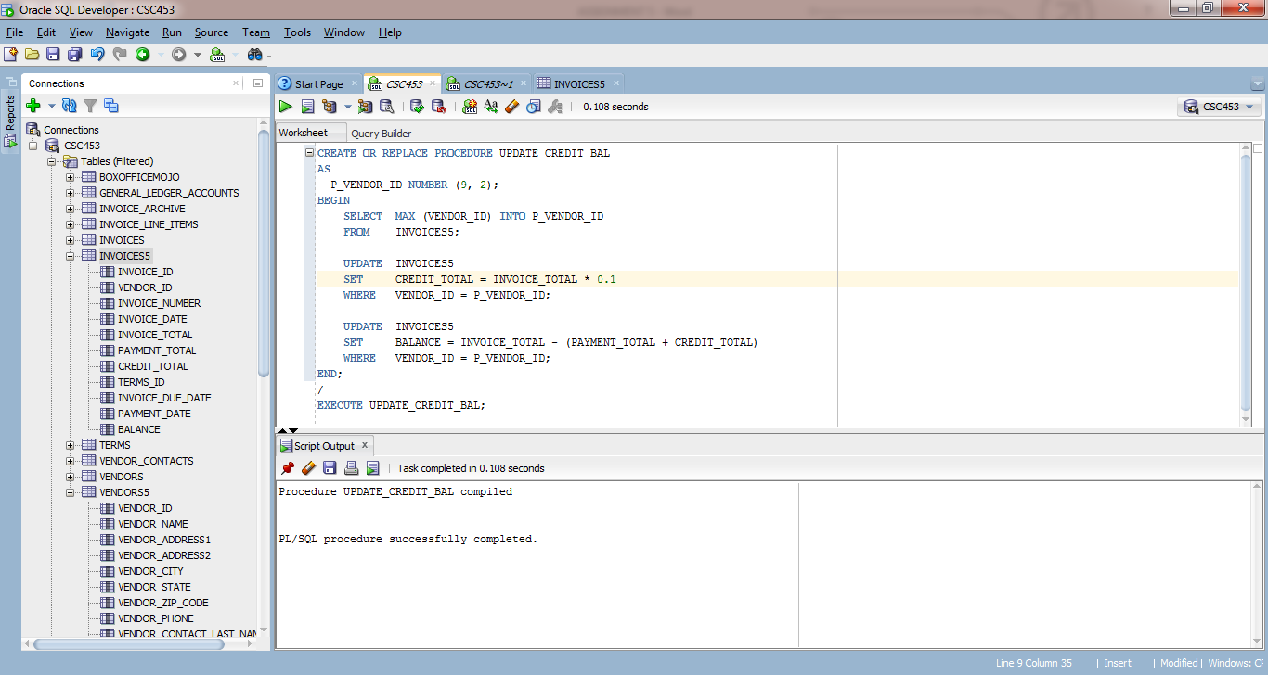

**Q3.A**

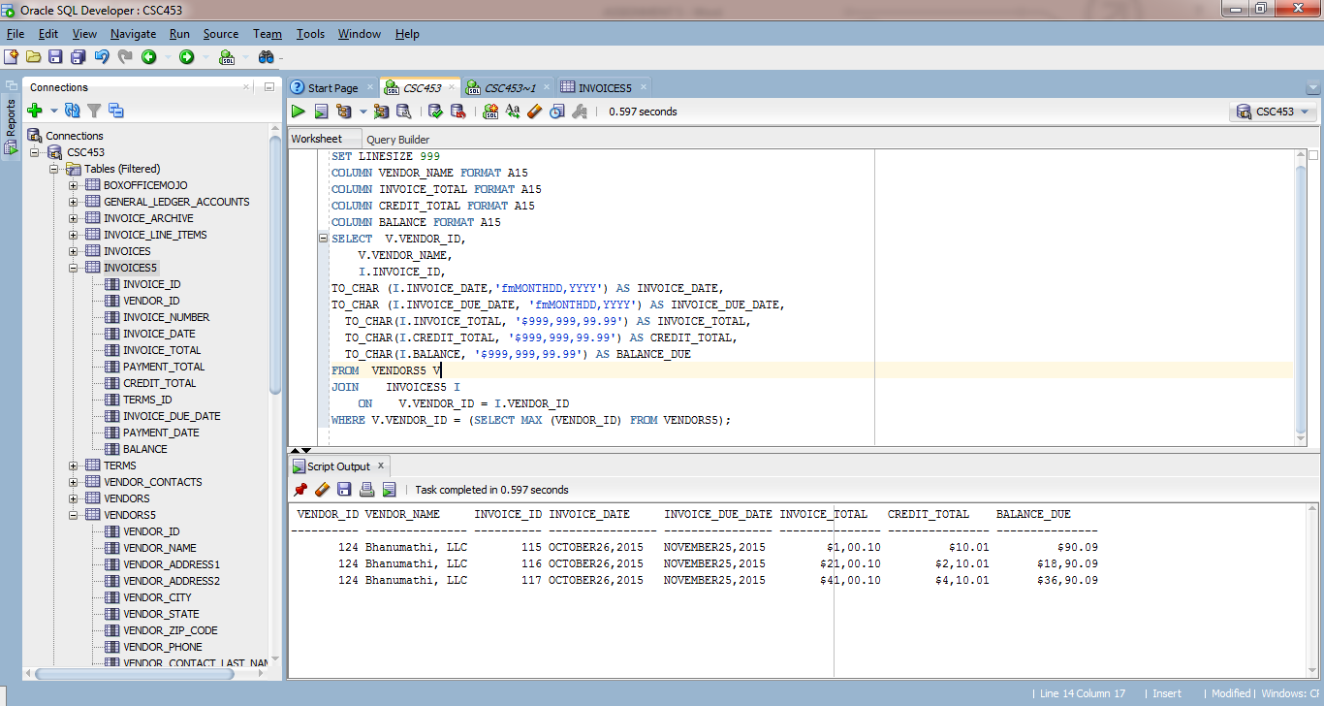

**Q3.B**

